Assignment 2 NetProg CWM
Yuzhe Jin
Brasenose College
Repository Link:

Sending MAC address of 00:00:00:00:00:02 from local machine to Raspberry Pi will not trigger any action from P4 scripts except returning back. As expected, Wireshark captures exact 200 packets as displayed in Fig 1.
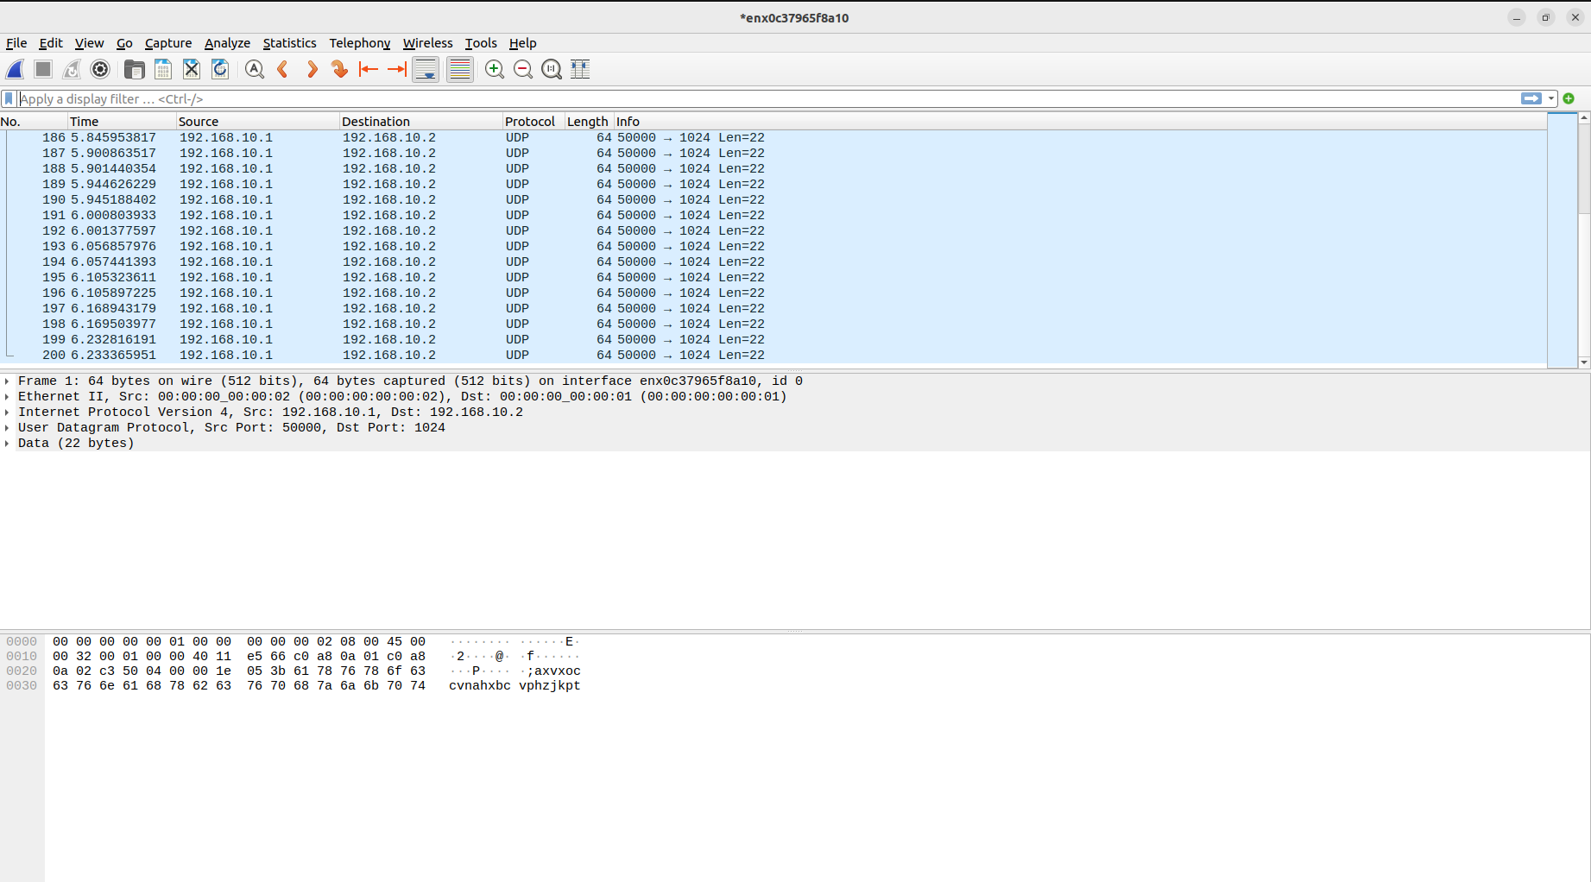
Fig 1
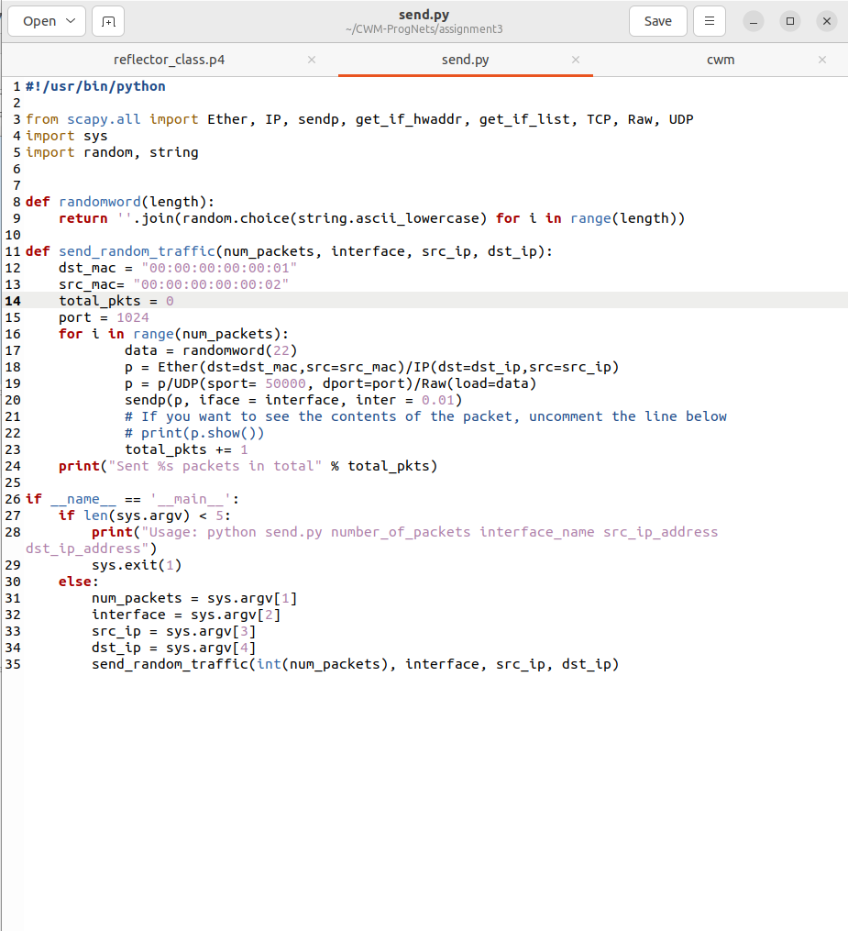

Fig 2 (Original send.py)

Just as expected, when we change the My_Ingress.drop code into 00:00:00:00:00:02, only 100 packets will be detected as the other 100 packets will be dropped off by the P4 programme as shown in Fig 3.
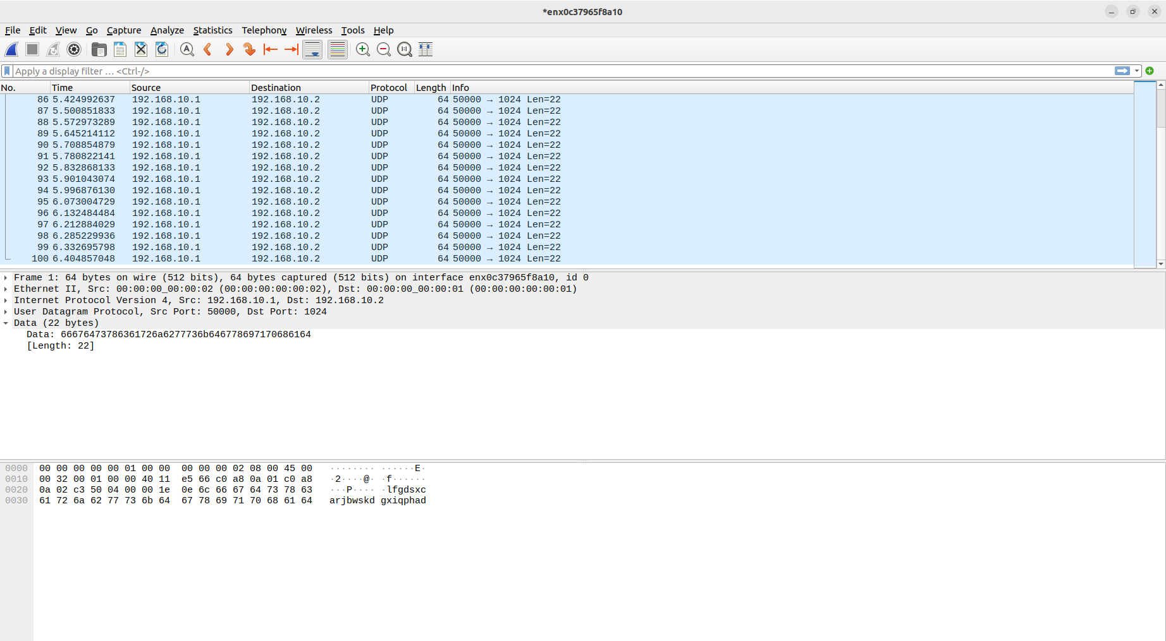
Fig 3
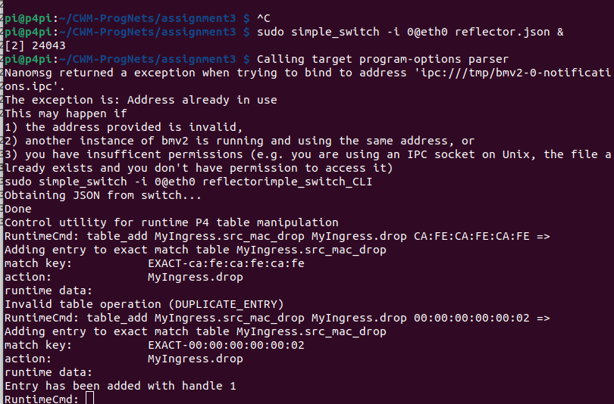
Fig 4

